Team members: Zhang,Xingxuan; Cadenhead, Casey; Sun, Haibo

Team number: 19

Class 7 Group Exercise

EX 3.16

1. Vertical
2. Neither
3. Horizontal

EX 3.17

1. Wider than its tall
2. Taller than wide
3. Wider than tall

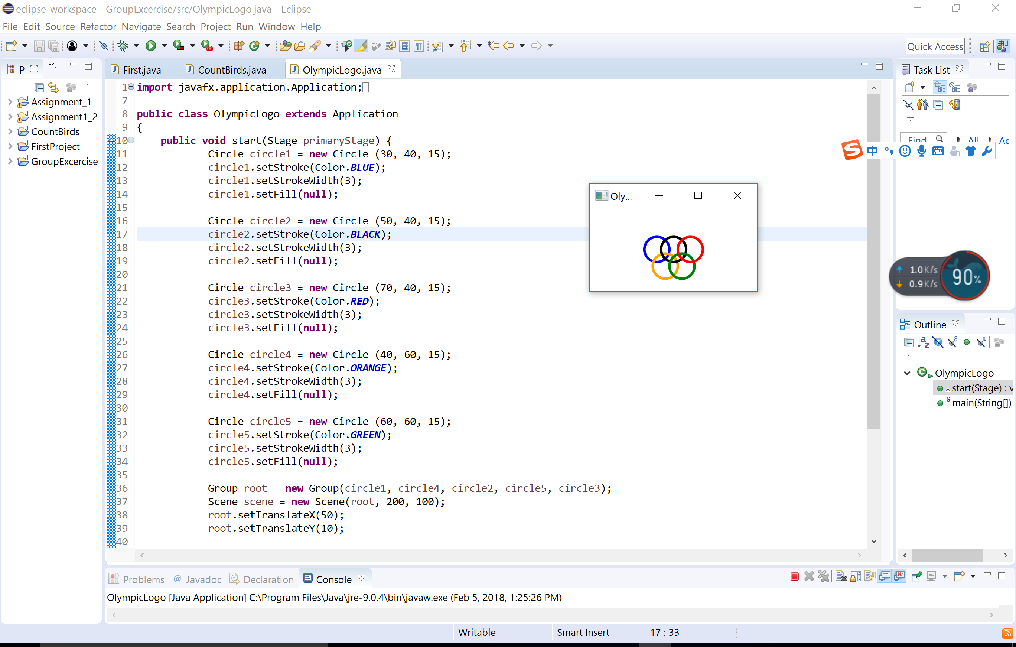

/********************************************************************

// OlympicLogo.java Author: Zhang,Xingxuan; Cadenhead, Casey; Sun, Haibo

//

// Draw Olympic Logo

//********************************************************************/

**import** javafx.application.Application;

**import** javafx.stage.Stage;

**import** javafx.scene.Group;

**import** javafx.scene.Scene;

**import** javafx.scene.paint.Color;

**import** javafx.scene.shape.*;

**public** **class** OlympicLogo **extends** Application

{

**public** **void** start(Stage primaryStage) {

Circle circle1 = **new** Circle (30, 40, 15);

circle1.setStroke(Color.***BLUE***);

circle1.setStrokeWidth(3);

circle1.setFill(**null**);

Circle circle2 = **new** Circle (50, 40, 15);

circle2.setStroke(Color.***BLACK***);

circle2.setStrokeWidth(3);

circle2.setFill(**null**);

Circle circle3 = **new** Circle (70, 40, 15);

circle3.setStroke(Color.***RED***);

circle3.setStrokeWidth(3);

circle3.setFill(**null**);

Circle circle4 = **new** Circle (40, 60, 15);

circle4.setStroke(Color.***ORANGE***);

circle4.setStrokeWidth(3);

circle4.setFill(**null**);

Circle circle5 = **new** Circle (60, 60, 15);

circle5.setStroke(Color.***GREEN***);

circle5.setStrokeWidth(3);

circle5.setFill(**null**);

Group root = **new** Group(circle1, circle4, circle2, circle5, circle3);

Scene scene = **new** Scene(root, 200, 100);

root.setTranslateX(50);

root.setTranslateY(10);

primaryStage.setTitle("Olympic");

primaryStage.setScene(scene);

primaryStage.show();

}

**public** **static** **void** main(String[] args) {

*launch*(args);

}

}